TOTAL REFLECTIVE ABSTRACTION
Selections from the Cassilhaus Collection
"Total Reflective Abstraction might be seen as an expression of our urge towards perfection itself, the secular corollary to a heaven in which thought and the body are one. As a visual modality it is infinite in its ability to project before us new perspectives, distortions, extensions. It is timeless, or perhaps it is time itself, because it only exists, as it exists, now, in the moment of looking.” -Josiah McElheny
1929: Isamu Noguchi and Buckminster Fuller walk into a bar and conceive of an entirely new mode of abstraction. Truly. Fuller, a theorist, engineer, designer, and author, was eventually to become best know for perfecting the Geodesic Dome while Noguchi, one time stone-cutter for Constantin Brancusi, would become renowned for both his furniture designs and his outdoor sculptural environments. The two met in Romany Marie’s in New York’s West Village and soon embarked on a collaboration that foreshadowed a trend in contemporary art and design that has never been fully examined. Their first aspiration was to create a sculpture without shadow. To achieve this aim they deduced that a totally reflective environment, where both object and surroundings were composed of mirrored surfaces, was necessary. Noguchi followed through on the idea by painting a small studio entirely silver and placing a chrome coated bust of Fuller inside. While the shadowless sculpture was realized, a new type of abstraction also emerged—one that is immersive and circuital; endlessly reflective and in turn, reflection inducing.
This was a one-time experiment, however, and the idea of Total Reflective Abstraction was not to be examined again for over seventy-five years through the sculpture and scholarship of Josiah McElheny. McElheny, who sought to fully realize this proposition in his work Total Reflective Abstraction, has fabricated a variety of Noguchi’s forms in silver and situated them on either a mirrored table or a completely mirrored chamber. As a photographer, I have often wondered if this opus of abstraction could be realized in a photograph. Is it possible to capture in a fraction of a second this idea of total immersion? Can a single image induce a stillness of mind and riot of the eye?
As it happens, many of the photographs in the Cassilhaus Collection court the spirit of Noguchi and Fuller’s concept, if not fully embody it. Total Reflective Abstraction at Cassilhaus draws a parenthesis around this theme in the collection with Martinque by André Kertész as the keystone. Both portrait and landscape, the image maps the possibility of both constructs by drawing the viewer to contemplate the contemplation of the subject, a silhouetted figure forever mediated by glass. The work is grounded in a legible image, clearly from life, yet the capacity for projection transcends the corners of the print rendering the still subject in constant flux. This is Total Reflective Abstraction at its photographic best.
Hiroshi Sugimoto speaks to this possibility in the spectacularly rendered photogravure U.A. Walker, New York 1978. In his series Theaters, Sugimoto employs a large format view camera to make an exposure for the duration of a film. The theater is captured in great detail while the silver screen is for once actually embodied as such, mirror-like. In speaking of his Seascape series where he aims his camera in similar fashion at the ocean, Sugimoto says, "I find a spot where I want to stay and then stay there sometimes a week, sometimes a couple weeks, sometimes 3 weeks, and then I just stay there and just feel like I’m a part of this nature and landscape. I start feeling this is the creation of the universe and I’m witnessing it."
I, for one, firmly believe, like Sugimoto, that through stillness and reflection a universe can be created. Cassilhaus was perhaps built with a similar intention in mind, and the collection of Frank Konhaus and Ellen Cassilly reflects their sympathy for this unapologetically modern idea.

--Lisa McCarty, Curator

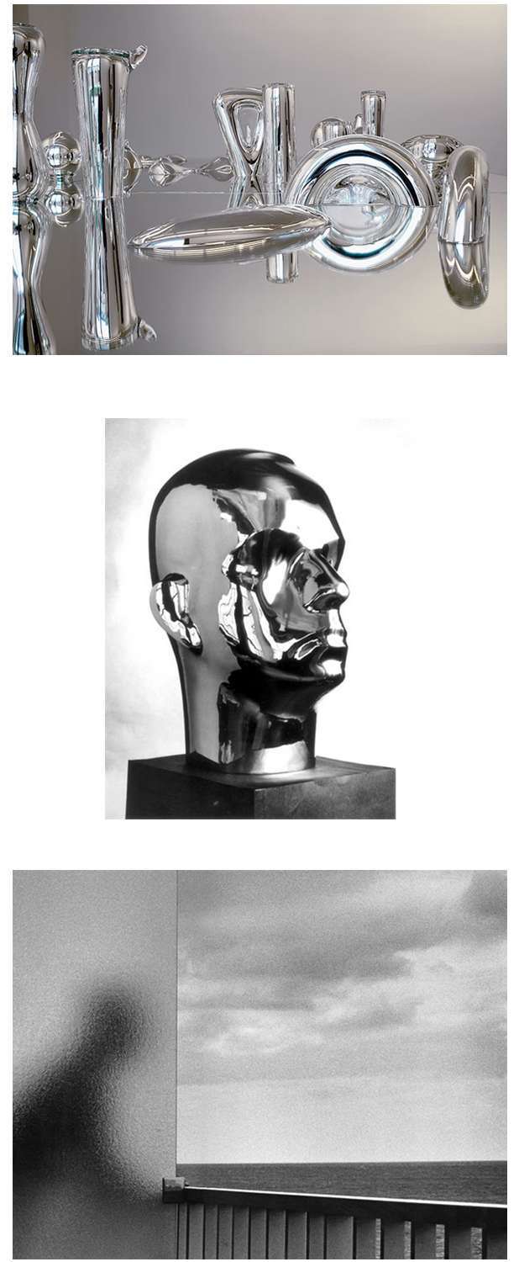

Josiah McElheny | Extended Landscape Model for Total Reflective Abstraction | 2005
Mirrored glass table with hand blown mirrored glass objects
Isamu Noguchi | R. Buckminster Fuller | 1929 | Chrome-plated bronze
André Kertész | Martinique | 1972/1975 | Vintage Gelatin Silver Print

TOTAL REFLECTIVE ABSTRACTION

Curated by Lisa McCarty

Cassilhaus Gallery

#1

Masao Yamamoto #121 from a Box of Ku nd

Japanese Toned Gelatin Silver Print 22/40

#2

Hiroshi Watanabe Agra Fort 2000

Japanese Gelatin Silver Print 1/15

#3

David Goldes Walk the Dog 1994

American Gelatin Silver Print 8/25

#4

John Menapace Untitled (Mirror Solo) 1982

American Gelatin Silver Print Open

#5

Frank Konhaus Analog TRAverse (for Lisa) 2012

American UK Suck Light Fixture with 25 35mm Slides 1992-2000 Unique

#6

André Kertész Martinique 1972/1975

Czech Vintage Gelatin Silver Print Open

#7

Mark Steinmetz Athens, GA (Girl on Car Hood) 1996

American Gelatin Silver Print 8/14

#8

Frank Hunter Curtain Saul to Paul 2000

American Platinum Paladium on Tissue 10/21

#9

Doug Keyes Eadweard Muybridge 2003

American Dye Coupler Print 23/30

#10

Hiroshi Sugimoto U.A. Walker, New York 1978 1978

Japanese Photogravure 500/1000

#11

John Menapace Untitled (Fox Talbot) 1980

American Gelatin Silver Print Open

#12

Caroline Hickman Vaughan Self Portrait, Father Mother 1977/2012

American Permanent Pigment Print Open

#13

Lee Friedlander Galax, Virginia 1962/2001

American Gelatin Silver Print Open

#14

Aaron Siskind Untitled (Broken Glass) 1947 1947

American Vintage Gelatin Silver Print Open

#15

Connie Imboden Dead Silences I 1988/2000

American Gelatin Silver Print 2/10

#16

Ryujie Room with a View 1989/2005

Japanese Gelatin Silver Print Open

#17

David Hilliard Green (Dyptic) 2003

American C-Print 2/5

#18

Michael Prince Kalia and TV Westchester 2002 2002

American C-Print 5/10

#19

Jack Spencer Cooter with Glass 1995

American Toned Gelatin Silver Print 21/50

#20

Kenneth Josephson Matthew, 1965 1965/2001

American Gelatin Silver Print 25/50

#21

Ray K. Metzker Philadelphia, 1963 1963/1986

American Gelatin Silver Print 14/15

#22

Elizabeth Matheson Hillsborough 1999

American Chromogenic Print Open

#23

Tito Sanpaolesi Vaporetto Venezia 1999

Italian Gelatin Silver Print 1/25

#24

Tamas Dezso Abandoned Room 2011

Hungarian Chromogenic Print 1/6

